EXPERIMENT -12
Hypothetical using Z-Test
Aim:
To test whether the average weight of species of bird differs from 150 grams

Procedure:
1. Null hypothesis
2. Alternative hypothesis
3. Sample
4. Z-Test
5. Decision Rule

Program:
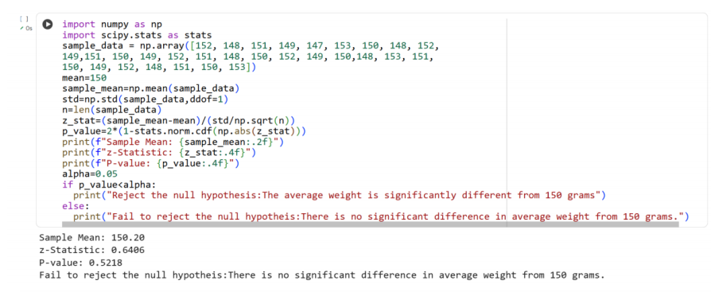
Result:
Thus the python program for doing hypothetical test using Z-Test is executed and
output is verified successfully

